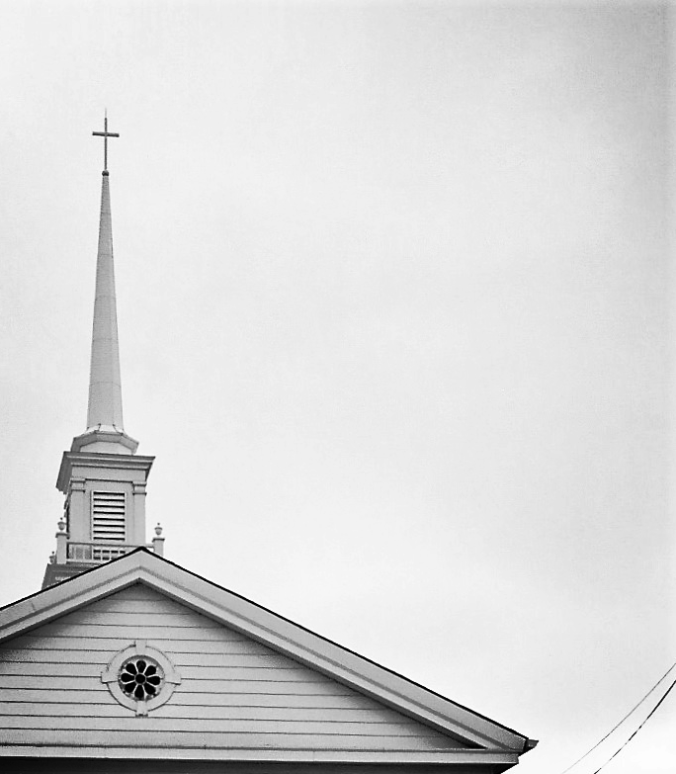
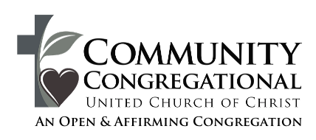

With the grace of God,
we will cultivate a compassionate
community that loves like Jesus,
grows in faith, and serves those
in need.

WE GATHER TO PRAISE GOD

Welcome/Announcements/Invocation

* Call To Worship:

Leader: Our worship is in the name of the Triune God – Creator, Redeemer, and Sustainer.
People: Amen.

Leader: Now is the moment of grace.
People: This is the hour of blessing.

Leader: Today is the day of salvation.
People: Today leads us toward the path to new life.

Leader: We want to move from war and hatred to love and peace.
People: Out of despair, we find hope in Christ. Out of fear, we gain trust in God’s promises.

Leader: Already joy is abounding and love is flowing,
People: For this is the day the Lord has made. Let us rejoice and praise God in our time of worship together!

* Opening Hymn - "O God You Call for Justice" lyrics by Carolyn Winfrey Gillette

* Passing of the Peace Greetings

WE LISTEN FOR GOD’S WORD

Children’s chat

Prayers of Illumination
Eternal God, you never fail to give us each day all that we ever need, and even more. Give us such joy in living and such peace in serving Christ, that we may gratefully make use of all your blessings, and joyfully seek our risen Lord in everyone we meet. In Jesus Christ we pray. Amen.

Sermon Scripture: Numbers 6: 22-27
Matthew 5: 1-12

Sermon “God Bless You!”

Prayer Response

Leader: Living God,
People: Bless us through the power of your Spirit

WE RESPOND TO GOD’S WORD

Responding in Song: “Amazing Grace”

arrangement by Jim Bryda and Chris Robinson

Prayers of the People

Responding with our Gifts

Musical Offering: “Here I Am, Lord"
by Dan Schutte

* The Doxology

WE DEPART TO DO GOD’S WORK

* Benediction and Blessing

* Closing Hymn “The Lord Bless You And Keep You”
Red Hymnal # 446

* We Bless Each Other “God Be with You” Using ASL

Those in Need of Prayer

CCUCC MEMBERS:
John Bassett, Holly McCain, Adam Szudarek, Karen Boas, Glenn Owen, Elaine Valentine, Terry Bruce, Marilyn Parker, Sally Hartley, Jessica Parsons, Judy Hutchinson, Ed Lotko, and Jim Keiser

(If any names need to be removed, please notify the church office)

FRIENDS OF CCUCC:

Upcoming Events

SUNDAY:
Lorain Community Meal @ 12:30pm

TUESDAY:
Guitar Club @ 6:30pm

THURSDAY:
Men’s Bible Study @ 7:00am



Worship Participants & Staff

379 South Main Street Rev. Brian Russell
Amherst, OH 44001 Minister
440.988.9148 call/text 336.420.7840

office@TheCCUCC.org pastor@TheCCUCC.org
www.TheCCUCC.org
Monday – Friday 9:00 am – 1:00 pm

Rev Brian Burke ……………………………………..Sabbatical Pastor

Emily Marty ………..….….………………….…………. Music Director

Carol Pullins ……. ……………………….……………….…….Vocals

Jim Bryda and Chris Robinson ………………………………….Guitar

Max Lotko ……………………………….……….… Bell Choir Director

Melissa Thompson …………………...…..……….…….Youth Director

Jenny Bliss ….……..…………………….…...……. Church Secretary

Cindi Manning …………………………….….…...………….Treasurer

John Herrmann …….….….…...……………..AV Production Manager

Please silence your cell phones.

If able, stand where marked with an asterisk (*).

A large print Bible & hymnal are available upon request.

PRAYER REQUESTS: Please email all prayer requests to the office at office@theccucc.org before Thursday at 10am. Requests can also be submitted by filling out the form in the back of the sanctuary.

PRAISE REPORTS: Please share with us how God has blessed you or a loved one! Forms can be found in the back of the sanctuary, or you can email office@theccucc.org before Thursday at 10am.

UPPER ROOM: We have copies of the JULY/AUGUST Upper Room available in the back of the sanctuary. Please contact the office via email at office@theccucc.org if you would like a copy mailed to you. The Sept/Oct issue will be available next Sunday, August 30th.



MEN’S BIBLE GROUP: The men’s group will meet on every Thursday at Commando Coffee Co., formally Sandstone Coffee, in Amherst from 7am-9am.

RALLY DAY: Join us for a fun, all-ages event on Sunday, September 13 for our 2026/2027 Sunday School Kick-off! Stick around after worship for treats, directory photos, and a donation sale of books, CD’s & misc. items in the Fellowship Hall.

2026/2027 SUNDAY SCHOOL Together We Light the World: Registration for Sunday School for the 2026/2027 year is now open! Go to theccucc.org and click on Sunday School form to register your youth.

CONFIRMATION CLASS OF 2027: Classes will begin in January. If you have a child in 8th grade or up who would like to be confirmed, please reach out to Melissa.


MISSION OF THE MONTH:
AMHERST CHILDREN’S BACKPACK MINISTRY
Your help is needed to provide food for over 100 students who need assistance on the weekends. There is a list of recommended items on the table outside the sanctuary.

CONNECT TO A CAUSE
Save the Date, September 17! Proceeds this year will benefit future youth mission trips.

