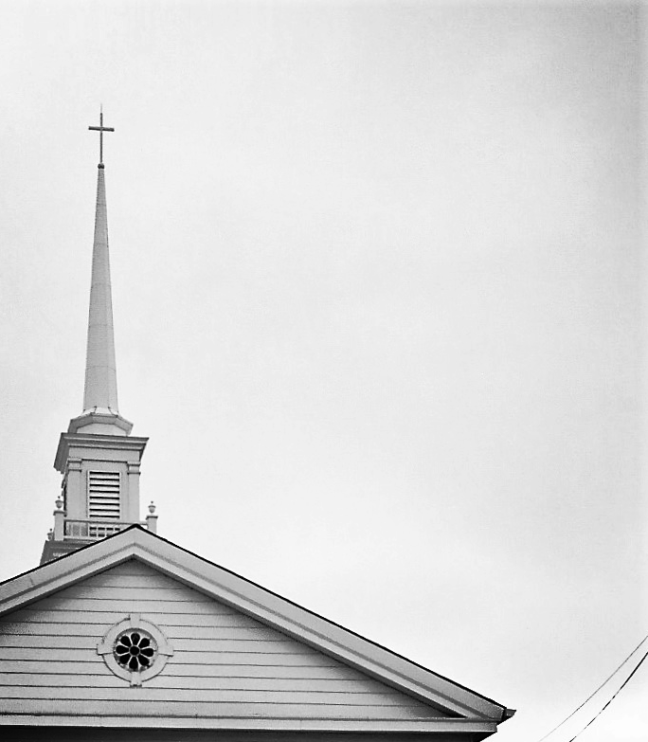
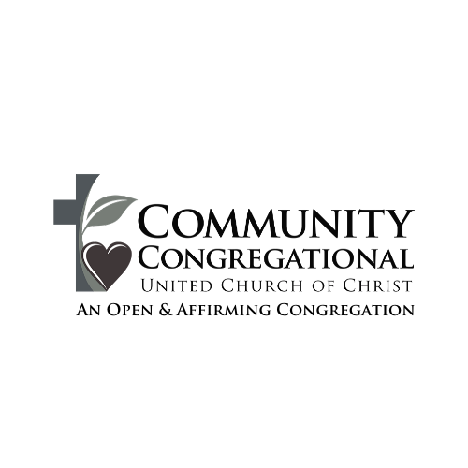

With the grace of God,
we will cultivate a compassionate
community that loves like Jesus,
grows in faith, and serves those
in need.

WE GATHER TO PRAISE GOD

Welcome/Announcements/Invocation

* Call To Worship:

Leader: We gather to worship in the name of our one true God – Creator, Christ, and Spirit.
People: Amen.
Leader: To the church in Philippi, Paul wrote: Let the same mind be in you that was in Christ Jesus.
People: Christ, though he was in the form of God, did not regard equality with God as something to be exploited, but emptied himself, taking the form of a slave, and being born in human likeness.
Leader: And being found in human form, he humbled himself and became obedient to the point of death – even death on a cross.
People: Therefore, God also highly exalted him and gave him the name that is above every name, so that at the name of Jesus every knee should bend, in heaven and on earth and under the earth, and every tongue should confess that Jesus Christ is Lord, to the glory of God the Father.
Leader: This morning, we bend our knees and speak our words to confess that Jesus Christ is, indeed, our Lord and Savior.
People: It is through the example of Jesus Christ that we offer our praise and thanks to God.
* Opening Hymn - " Rejoice, You Pure in Heart " Black Hymnal #55

* Passing of the Peace Greetings

WE LISTEN FOR GOD’S WORD

Children’s chat

Prayer of Illumination:
Calm us now, O Lord, into a quietness that heals and listens. Unlock prideful hearts to the humility in your Word. Open wounded hearts to the healing balm of your Word. Soften hardened hearts to the compassionate love of your Word. Speak to us in clear tones so that we might feel our spirits leap for joy and skip with hope as your resurrection witnesses. Amen.

Scripture: Philippians 4:2-14

Sermon: “From Prison to Purpose”

WE RESPOND TO GOD’S WORD

musical response: “Stand By Me”
by Ben E. King

Prayers response:

In your great mercy,
Lord, hear our prayer.

Responding with our Gifts

Offering song: “The Lord's Prayer”

* Doxology

WE DEPART TO DO GOD’S WORK

* Commission & Benediction
Leader: We go now in peace, for Christ has called us to live in peace among our brothers and sisters in Christ.
People: We go now in courage, for Christ has called us from the places of our lives to be agents of redemption and partners in healing.
Leader: We go now in joy and thanksgiving, for Christ is our light.
People: We go now as one body, to love and serve God as we love and serve our neighbors in the world.

* closing hymn: “I'll Stand By You “

by The Pretenders

* we bless each other: “God Be with You”

Using ASL

Those in Need of Prayer

CCUCC MEMBERS:
John Bassett, Holly McCain, Adam Szudarek, Karen Boas, Elaine Valentine, Terry Bruce, Marilyn Parker, Jessica Parsons, Judy Hutchinson, Ed Lotko, Jim Keiser, Catie Strohmeyer, Cindi Manning and Rick Cullen

FRIENDS & FAMILY OF CCUCC:
Don Szabo, Brenda Warren, Michael Golden

Upcoming Events

MONDAY
Amherst Community Meal @ 5:00pm

TUESDAY
Pews & Views Church Tour @ 5:30pm
Guitar Club @ 6:30pm

WEDNESDAY
Choir @ 6:00pm
Bells @ 7:00pm

THURSDAY
Men’s Bible Study @ 7:00am
Women’s Bible Study @ 10:00am


Worship Participants & Staff

379 South Main Street Rev. Brian Russell
Amherst, OH 44001 Minister
440.988.9148 call/text 336.420.7840
office@TheCCUCC.org pastor@TheCCUCC.org
www.TheCCUCC.org
Monday – Friday 9:00 am – 1:00 pm

Rev. Brian Burke ….….………………..…………….Sabbatical Pastor

Emily Marty ………..….….………………….………….. Music Director

Linda Rothgery…………………………………………….……..Liturgist

Choir, Alex Baker, Elizabeth Russell .....….……………….……Vocals

Nancy Golden ……………………………………………………….Flute

Alex Baker ………………………… ……………..………………Guitar

Jim Bryda ……………………………………………………......….Bass

Russ Marty ………………………………………………………...Drums

Max Lotko …………………………………..……… Bell Choir Director

Melissa Thompson …………………...….….…….…….Youth Director

Jenny Bliss ….……..…………………….…………. Church Secretary

Cindi Manning …………………………………..…………….Treasurer

John Herrmann …….….….…...……………..AV Production Manager

Please silence your cell phones.

If able, stand where marked with an asterisk (*).

A large print Bible & hymnal are available upon request.

PRAYER REQUESTS: Please email all prayer requests to the office at office@theccucc.org before Thursday at 10am. Requests can also be submitted by filling out the form in the back of the sanctuary.

PRAISE REPORTS: Please share with us how God has blessed you or a loved one! Forms can be found in the back of the sanctuary, or you can email office@theccucc.org before Thursday at 10am.

UPPER ROOM: We have copies of the Sept/Oct Upper Room available in the back of the sanctuary. Please contact the office via email at office@theccucc.org if you would like a copy mailed to you.



AMHERST COMMUNITY MEAL: Monday @ 5:00pm

PEWS & VIEWS CHURCH TOUR: Starts with a light meal on Tuesday @ 5:30pm, followed by the tour @ 6:oopm

GUITAR CLUB: The guitar club meets every Tuesday at 6:30pm.

VOCAL & BELL CHOIR: Vocal Choir & Bell Choir meet every Wednesday at 6pm & 7pm respectively.

MEN’S BIBLE GROUP: The men’s group meets every Thursday at Commando Coffee Co. in Amherst from 7 - 9am.

WOMEN’S BIBLE GROUP: The women’s group meets on Thursday @ 10:00am.



MISSION OF THE MONTH:
NEIGHBORS IN NEED
Neighbors in Need (NIN) is a Special Mission Offering of the United Church of Christ that supports ministries of justice and compassion, with one-third of the offering given to the Council for American Indian Ministries and the remaining two-thirds supporting UCC justice ministries. In 2025, the Neighbors in Need offering supported 26 grants recipients across the UCC who were engaged in projects of direct service and advocacy. When you give to Neighbors in Need, you help build a just world for all. Thank you!
